**Hackathon Project Phases Template**

**Project Title:**

FitSync AI - Your Personal Fitness Coach

**Team Name:**

Team 234

**Team Members:**

* U. Anjali
* P. Anjana Sai Sarayu
* G. Beula Rani

**Phase-1: Brainstorming & Ideation**

**Objective:**

Develop an AI-powered fitness coaching tool using Generative AI (Gemini AI) and Streamlit to provide personalized workout coaching, meal planning, and motivational support.

**Key Points:**

1.​ **Problem Statement:​**

* Many individuals struggle to maintain a consistent and effective fitness routine.
* Users need personalized guidance on exercises, nutrition, and hydration to achieve their fitness goals.

2.​ **Proposed Solution:​**

* An AI-driven app that offers personalized workout advice, meal planning, water intake tracking, and motivational support.
* The app utilizes the Gemini AI model for generating personalized health insights and Streamlit for a responsive and interactive UI.

.

3.​ **Target Users:​**

* Fitness enthusiasts looking for customized workout plans.
* Individuals aiming for specific health goals like weight loss, muscle gain, or improved endurance.
* Users needing consistent reminders and support to stay motivated.

4.​ **Expected Outcome:​**

A functional AI-powered fitness app providing real-time advice, meal plans, and tracking

Features.

**Phase-2: Requirement Analysis**

**Objective:**

Define the technical and functional requirements for the FitSync AI app.

**Key Points:**

|  |  |  |
| --- | --- | --- |
|  | **1.Technical Requirements:​** | |
|  | ○​ |  |
|  | ○​ | * **Programming Language: Python** * **Frontend:** Streamlit Web Framework |
|  | ○​ | * **Backend:** Gemini AI via Generative API |
|  | ○​ | * **Database:** In-memory data storage (no external database needed) |
| 2.​ | **Functional Requirements:​** | |
|  |  | * Provide personalized workout advice using the Gemini AI model. * Generate AI-driven meal plans based on user data. * Track water intake and progress towards hydration goals. |
|  |  |  |
|  |  |  |
|  |  |  |
|  | ○​ |  |
| 3.​ | **Constraints & Challenges:​** | |
|  | ○​ | Handling API rate limits effectively. |
|  | ○​ | Maintaining real-time responsiveness of the UI. |
|  | ○​ | Ensuring email notifications are reliable and timely |

**Phase-3: Project Design**

**Objective:**

Develop the architecture and user flow of the application.

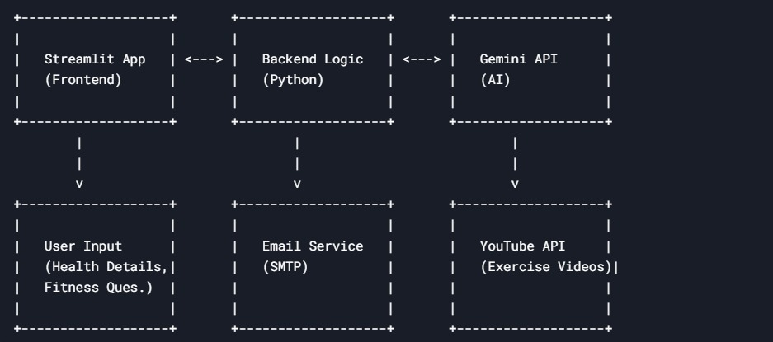

**Key Points:**

1.​ **System Architecture:​**

* User inputs fitness data via the Streamlit interface.
* Gemini AI processes the input to generate personalized advice.
* The frontend displays workout, meal, and hydration insights.

2.​ **User Flow:​**

* Step 1: User enters health details and workout data.
* Step 2: Backend uses the Gemini AI model to analyze and provide suggestions.
* Step 3: App displays advice and offers motivational support.

3.​ **UI/UX Considerations:​**

* **Minimalist, user-friendly interface** for seamless navigation.
* Simple, clean interface with intuitive navigation.
* Visual indicators of progress (e.g., water intake tracking).

**Phase-4: Project Planning (Agile Methodologies)**

**Objective:**

Break down development tasks for efficient completion.

|  |  |  |  |  |  |  |  |  |
| --- | --- | --- | --- | --- | --- | --- | --- | --- |
|  |  |  |  |  |  |  | **Expected** |  |
| **Sprint** | **Task** | **Priority** | **Duration** | **Deadline** | **Assigned To** | **Dependencies** | **Outcome** |  |
|  |  |  |  |  |  |  |  |  |
|  |  |  |  |  |  | Google API Key, | API connection |  |
|  | Environment Setup |  | 6 hours | End of Day |  | Python, Streamlit | established & |  |
| 1 | & API Integration | High | (Day 1) | 1 | Anjali | setup | working |  |
|  |  |  |  |  |  |  |  |  |
|  |  |  |  |  |  |  |  |  |
| 1 | Basic UI Development |  | 3 hours | End of Day | Anjana | API response | Basic UI with input |  |
|  | Medium | (Day 1) | 1 | format finalized | fields |  |
|  |  |  |  |  |  |  |  |  |
|  | Core Features & Debugging |  | 3 hours |  |  | API response, UI | Search functionality |  |
| 2 |  | High | (Day 2) | Mid-Day 2 | Beula | elements ready | with filters |  |
|  |  |  |  |  |  |  |  |  |
|  | Testing, Enhancements & Submission |  | 1.5 hours |  |  | API logs, UI | Improved API |  |
| 3 |  | Medium | (Day 2) | Mid-Day 2 | Entire Team | inputs | stability |  |
|  |  |  |  |  |  |  |  |  |

**Phase-5: Project Development**

**Objective:**

Implement core features of the FitSync AI app.

**Key Points:**

1.​ **Technology Stack Used:​**

* **Frontend:** stream lit
* **Backend:** Gemini AI(via Google Generative API)
* ​**Programming Language:** Python

2.​ **Development Process:​**

* ​Implement API key authentication and integrate Gemini AI.
* Develop core functionalities: workout advice, meal planning, water intake tracking, and reminders.
* Enhance the UI for a better user experience.

3.​ **Challenges & Fixes:​**

* **Challenge:** Managing API rate limits.
* **Fix:** Optimize API calls and implement error handling.
* **Challenge:** Ensuring accurate and personalized responses.
* **Fix:** Fine-tune prompts for the Gemini AI model

**Phase-6: Functional & Performance Testing**

**Objective:**

Ensure that the AutoSage App works as expected.

|  |  |  |  |  |  |
| --- | --- | --- | --- | --- | --- |
| **Test** |  |  |  |  |  |
| **Case ID** | **Category** | **Test Scenario** | **Expected Outcome** | **Status** | **Tester** |
|  |  |  |  |  |  |
|  |  |  |  |  |  |
| TC-001 | Functional Testing | User inputs workout data | Generate personalized workout advice | Passed | TC-001 |
| TC-002 | Performance Testing | API response time under 500ms | Quick and accurate AI responses | Passed | TC-002 |
| TC-003 | Validation Testing | Ensure email reminders are sent | Emails delivered on schedule | Passed | TC-003 |
| TC-004 | UI Testing | Ensure responsiveness on devices | UI adapts to all screen sizes | Passed | TC-004 |
|  |  |  |  |  |  |
|  |  |  |  |  |  |

**Final Submission**

1.​ **Project Report Based on the templates**

2.​ **Demo Video (3-5 Minutes)**

3.​ **GitHub/Code Repository Link**

4.​ **Presentation**